**Exercise 1**

package com.library.repository;

public class BookRepository {

    public String getBookNameById(int id) {

        //dummy

        return "Book#" + id + ": Found";

    }

}

package com.library.service;

import com.library.repository.BookRepository;

public class BookService {

    private BookRepository bookRepository;

    // Setter for dependency injection

    public void setBookRepository(BookRepository bookRepository) {

        this.bookRepository = bookRepository;

    }

    public void printBookName(int id) {

        String bookName = bookRepository.getBookNameById(id);

        System.out.println("Retrieved Book: " + bookName);

    }

}

**Pom.xml**

<dependencies>

    <!-- https://mvnrepository.com/artifact/org.springframework/spring-core -->

    <dependency>

        <groupId>org.springframework</groupId>

        <artifactId>spring-core</artifactId>

        <version>7.0.0-M6</version>

    </dependency>

**MainApp.java**

package com.library;

import com.library.service.BookService;

import org.springframework.context.ApplicationContext;

import org.springframework.context.support.ClassPathXmlApplicationContext;

public class MainApp {

    public static void main(String[] args) {

        // Load Spring context from XML

        ApplicationContext context = new ClassPathXmlApplicationContext("applicationContext.xml");

        // Get the bookService bean

        BookService bookService = context.getBean("bookService", BookService.class);

        // Call the service method

        bookService.printBookName(101);

    }

}

**OUTPUT**

>mvn clean compile

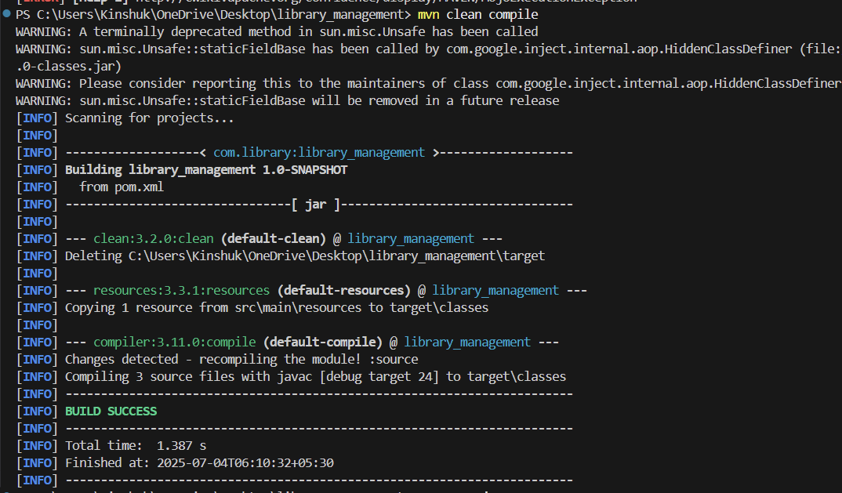

>mvn exec:java

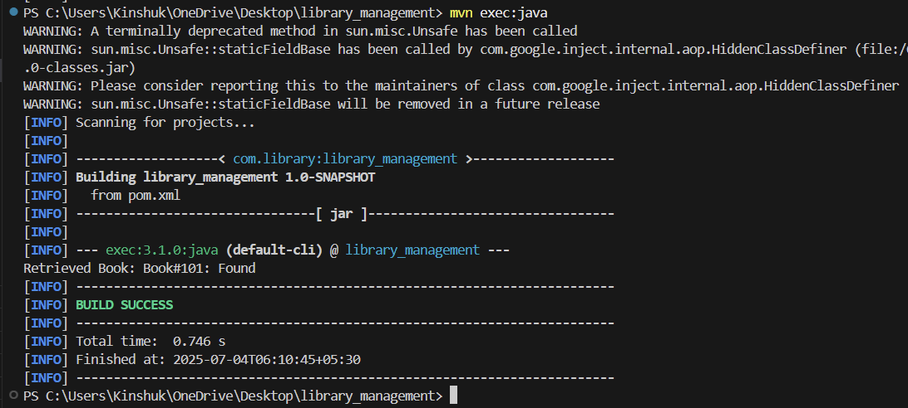

**Exercise 2:**

package com.library.service;

import com.library.repository.BookRepository;

public class BookService {

    private BookRepository bookRepository;

    // Setter for dependency injection

    public void setBookRepository(BookRepository bookRepository) {

        this.bookRepository = bookRepository;

    }

    public void printBookName(int id) {

        String bookName = bookRepository.getBookName(id);

        System.out.println("Retrieved Book: " + bookName);

    }

}

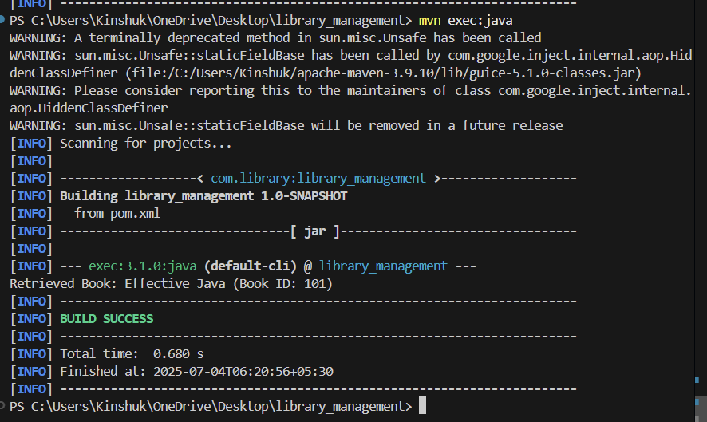

**Exercise 3**

**Adding dependencies**

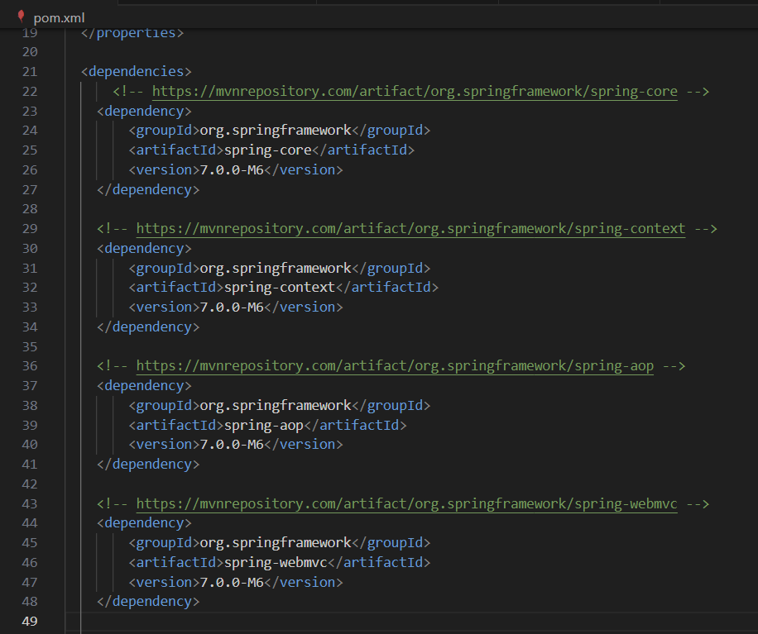

**Updating the JAVA version**

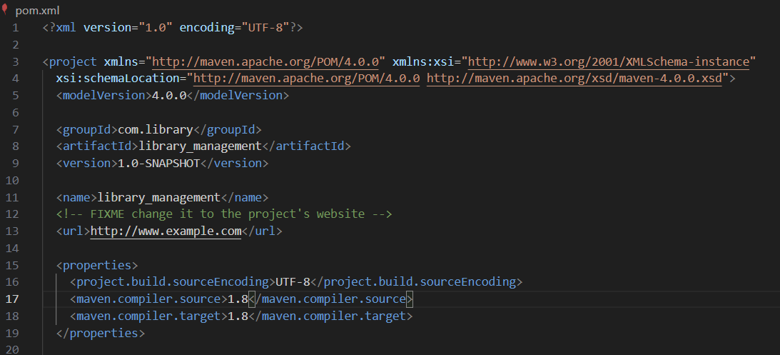

**Compilation success**

